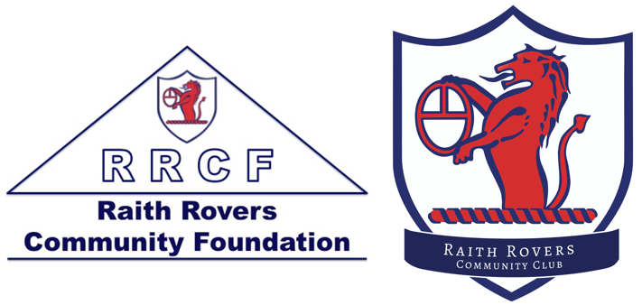
Raith Rovers Community Club
Return to Play
Randolph Playing Fields

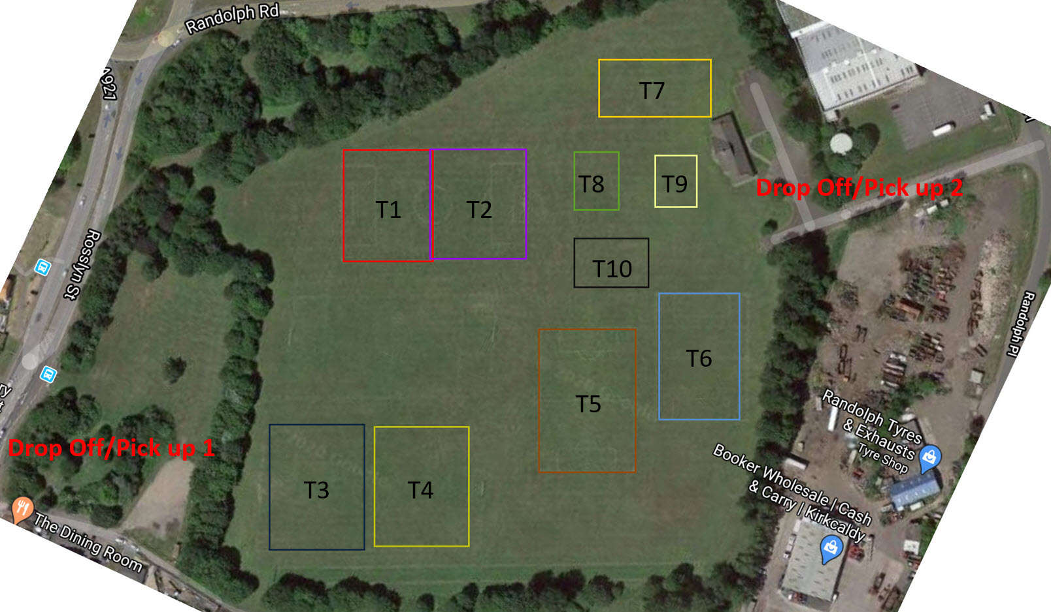

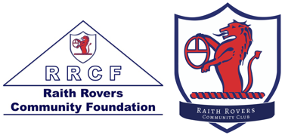
Health & Hygiene
- Do NOT leave your home to coach the sessions if you or someone you live with has or has had symptoms of COVID-19. Contact the office as soon as possible, call 111 and arrange for a test.
- 2-meter physical distancing must be maintained at all times, including parents collecting their children.
- If you need to sneeze or cough, do so into a tissue or upper sleeve. Dispose of your tissue into the bin on the Astro or place it in a plastic bag and take it home. Wash your hands afterwards for a minimum of 20 seconds.
- Avoid touching your face and ensure that you clean your hands with at least 60% alcohol gel when you finish coaching.
- If you are symptomatic you must self-isolate for 7 days and household members for 14 days in line with NHS guidance.
- All coaching is to take place outdoors
- All equipment should be disinfected prior to and on conclusion of every session.
- Upon arrival at home after a coaching session, clothes should be immediately put into a bag or put into a washing machine and be washed.
Child Wellbeing
- You must adhere to the child welfare policy of the Trust at all times.
Before the Session
- Training zones (T1-T10)will be allocated to teams upon availability, suitability and demand
- You must travel to the session in your own car, no car sharing is permitted outside your household.
- 2-meter physical distancing must be maintained at all times, including parents collecting their children.
- There are two designated Pick up/Drop off points 1 & 2 as identified on the map
- Pick up point 1 should be used for T1-T4
- Pick up point 2 should be used for T5-T10
- Use the non-contact thermometer to take the temperature of everyone at the identified stopping point in the carpark. The thermometer allows the coach to maintain social distancing. Anyone with a reading above 37.8° cannot enter the pitch
- All players must sign in and sign out of every session. Coaches should complete registers in full for every session.
- Wash your hands with soap and water for at least 20 seconds before leaving home to go to training (or use a 60% alcohol gel if washing hands is not possible). A mobile hand sanitising station will be available to be used at pitch or your coach will have hand sanitiser for you to use.
- Parents should avoid attending pitch side during any training sessions.

Equipment
- One football per child, no sharing of equipment. This includes bibs and cones. Bibs should not be used.
- Only take out the equipment that you need for the session.
- Ensure that participants do not share water bottles or food.
- Check that participants take all their equipment away at the end of the session: the changing rooms are not in use.
- Children can wear masks and gloves for the session if they wish. They must provide their own PPE.
- Coaches can wear masks and gloves for the session if they wish.
The Session
- Make the session fun!
- It is important not to push the players too hard and cause an increased risk of injury.
- The session will be different because of physical distancing so consider this before you organise the session.
- Physical intensity should start low and increase gradually.
- Handshakes, high fives and group celebrations are not allowed.
- Please avoid using your hands at any stage during the activity.
- Spitting is not allowed.
- Heading is not allowed.
- Although physical fitness is something which may have decreased during this break, the focus should be on technical and tactical development.
- No goalkeeping.
- Make sure that activity is appropriate for the age and stage of the player.
- Players should stay well hydrated at all times drinking plenty of water with regular small sips from their own bottle.
- No first aid should be administered unless life is at risk.
- You must maintain an accurate register of attendees, times and dates to allow contact tracing if required.
- Coaching content must follow the principles of physical distancing and avoiding contact.
- It is the coach’s responsibility to inform all players and parents of the Pickup and drop off points, including hand sanitising on arrival and departure.
- Coaches must follow all the guidance with respect to child wellbeing.
- Stray footballs should be kicked/dribbled back to position and not picked up.
- Use of toilets will be allowed at the discretion of the coaches, only the use of designated toilets will be allowed, which will be cleaned after each session if used

After the Session
- Spray and wipe down the balls and cones.
- Do not use bibs.
- Clean sinks/toilets if used, using the specific products in the facilities.
- There is 30 minutes between the sessions to avoid crossover of participants and to give time to disinfect everything.

This is a live document that will be updated as per guidance issued by the SFA and SYFA

Raith Rovers Community Club
Return to Play
Gallatown Playing Fields

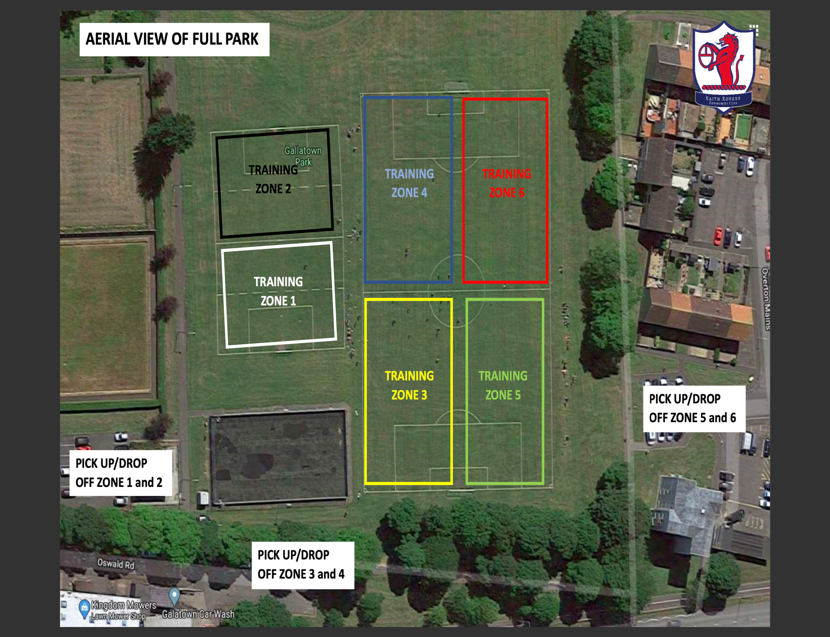

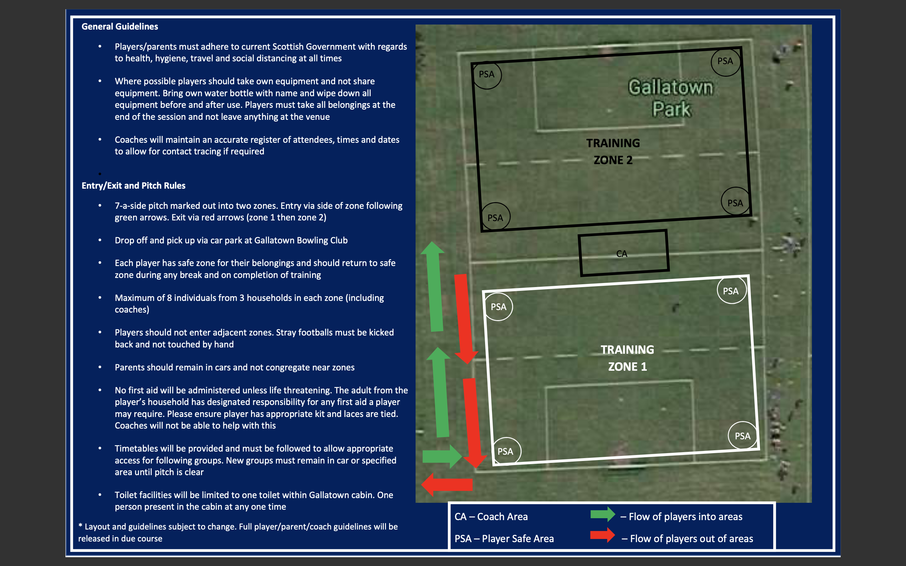
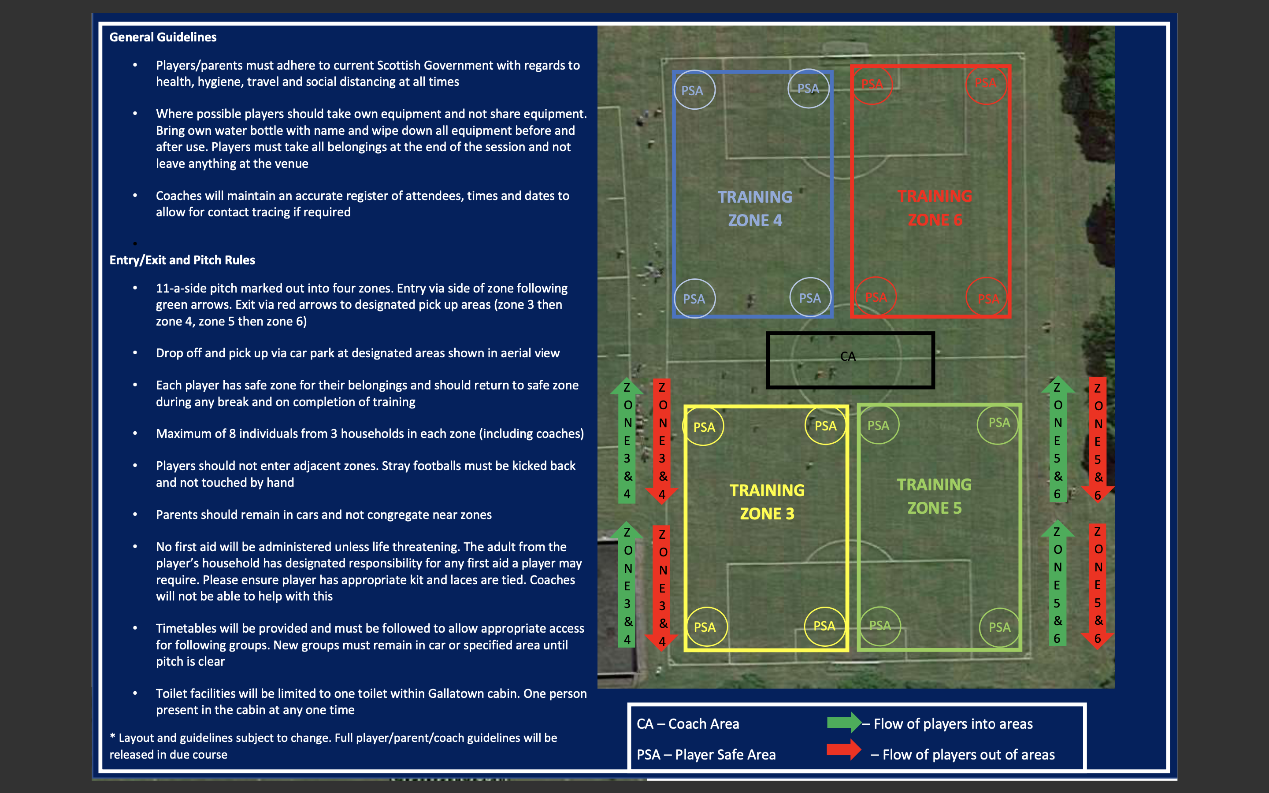

Health & Hygiene
- Do NOT leave your home to coach the sessions if you or someone you live with has or has had symptoms of COVID-19. Contact the office as soon as possible, call 111 and arrange for a test.
- 2-meter physical distancing must be maintained at all times, including parents collecting their children.
- If you need to sneeze or cough, do so into a tissue or upper sleeve. Dispose of your tissue into the bin or place it in a plastic bag and take it home. Wash your hands afterwards for a minimum of 20 seconds.
- Avoid touching your face and ensure that you clean your hands with at least 60% alcohol gel when you finish coaching.
- If you are symptomatic you must self-isolate for 7 days and household members for 14 days in line with NHS guidance.
- All coaching is to take place outdoors
- All equipment should be disinfected prior to and on conclusion of every session.
- Upon arrival at home after a coaching session, clothes should be immediately put into a bag or put into a washing machine and be washed.
Child Wellbeing
- You must adhere to the child welfare policy of the Trust at all times.
Before the Session
- Training zones (T1-T6) will be allocated to teams upon availability, suitability and demand
- You must travel to the session in your own car, no car sharing is permitted outside your household.
- 2-meter physical distancing must be maintained at all times, including parents collecting their children.
- There are three designated Pick up/Drop off points 1, 2 & 3 as identified on the map
- As per the map pick-up and drop zones should be used according to training zone assigned.
- Use the non-contact thermometer to take the temperature of everyone at the identified stopping point in the carpark. The thermometer allows the coach to maintain social distancing. Anyone with a reading above 37.8° cannot enter the pitch
- All players must sign in and sign out of every session. Coaches should complete registers in full for every session.
- Wash your hands with soap and water for at least 20 seconds before leaving home to go to training (or use a 60% alcohol gel if washing hands is not possible). Hand sanitiser will be available from your coach.
- Parents should avoid attending pitch side during any training sessions.
Equipment
- One football per child, no sharing of equipment. This includes bibs and cones. Bibs should not be used.
- Only take out the equipment that you need for the session.
- Ensure that participants do not share water bottles or food.
- Check that participants take all their equipment away at the end of the session: the changing rooms are not in use.
- Children can wear masks and gloves for the session if they wish. They must provide their own PPE.
- Coaches can wear masks and gloves for the session if they wish.
The Session
- Make the session fun!
- It is important not to push the players too hard and cause an increased risk of injury.
- The session will be different because of physical distancing so consider this before you organise the session.
- Physical intensity should start low and increase gradually.
- Handshakes, high fives and group celebrations are not allowed.
- Please avoid using your hands at any stage during the activity.
- Spitting is not allowed.
- Heading is not allowed.
- Although physical fitness is something which may have decreased during this break, the focus should be on technical and tactical development.
- No goalkeeping.
- Make sure that activity is appropriate for the age and stage of the player.
- Players should stay well hydrated at all times drinking plenty of water with regular small sips from their own bottle.
- No first aid should be administered unless life is at risk.
- You must maintain an accurate register of attendees, times and dates to allow contact tracing if required.
- Coaching content must follow the principles of physical distancing and avoiding contact.
- It is the coach’s responsibility to inform all players and parents of the Pickup and drop off points, including hand sanitising on arrival and departure.
- Coaches must follow all the guidance with respect to child wellbeing.
- Stray footballs should be kicked/dribbled back to position and not picked up.
- Use of toilets will be allowed at the discretion of the coaches, only the use of designated toilets will be allowed, which will be cleaned after each session if used

After the Session
- Spray and wipe down the balls and cones.
- Do not use bibs.
- Clean sinks/toilets if used, using the specific products in the facilities.
- There is 30 minutes between the sessions to avoid crossover of participants and to give time to disinfect everything.

This is a live document that will be updated as per guidance issued by the SFA and SYFA

